**Contents:**

**Introduction---------------------------------------------------------------------------------------------------------------------- 3**

**ER diagrams and explanations ---------------------------------------------------------------------------------------------- 3**

**Solution of given topic (Comments)--------------------------------------------------------------------------------------- 5**

**Result (suggestions)----------------------------------------------------------------------------------------------------------- 11**

**References ---------------------------------------------------------------------------------------------------------------------- 11**

**Introduction:**

In modern life every industry should be digitalized. In retail sector it is essential topic. As it is known that supermarkets should handle huge amount of orders, sales and manage all data related to internal business processes. For this reason, several technical solutions are worked by companies. One of the common problems is to keep all information and details about products, orders , sales and etc.

This project solves problems of supermarket in case of data management and information retrievals. Multiple linked tables in storemanagement schema makes jobs done easily, increase efficiency and productivity.

**General Information:**

As a database management system(DBMS) MySQL was used. 8.0.13 version of MySQL. For the project, joins, views, select, update, delete, insert, constraints, filters, alter operations used in different kind of purposes. Firstly, I made a list of my needs and started to design necessary tables and their relationship statuses. As a result, I got ER diagram that will direct me during further processes.

**ER diagram:**

An entity–relationship model describes interrelated things of interest in a specific domain of knowledge. A basic ER model is composed of entity types and specifies relationships that can exist between entities.

In the given picture(Figure 1) taken from database system(detailed information will be in next paragraphs) you can see all details about table structures and primary-foreign key relationships;

**Explanation:**

**Users table** describes all information about users . **Orders table** keeps recording of details of **Users’ order** to the Supplier demanding new products for selling. **Sales table** holds basic information about **Users’ sales**(payment, date and cashier identity). **Sales_detailed** **table** is responsible for given detailed description about Sales amount, product etc. **Categories table** is for keeping information about category types of products in market such as dairy, fruits, bakery and so on. **Status_sales** **table** describes status of a product such as active(saleable), frozen(is not allowed to sell), deleted(not in the system). **Product_type** table holds types of product(piece, weighted and etc). **Status_Orders table** describes current status of given orders. For example, Status of ordered product by market can be awaiting(waiting for delivery), canceled or received(by market reception). **Supplier table** holds all information about suppliers, contracts(start and end dates). Products table is the biggest and most related table of system. It combines **Categories**, **Supplier, Status_sales, Product_type** and additional product information. All ids are auto increment in tables.

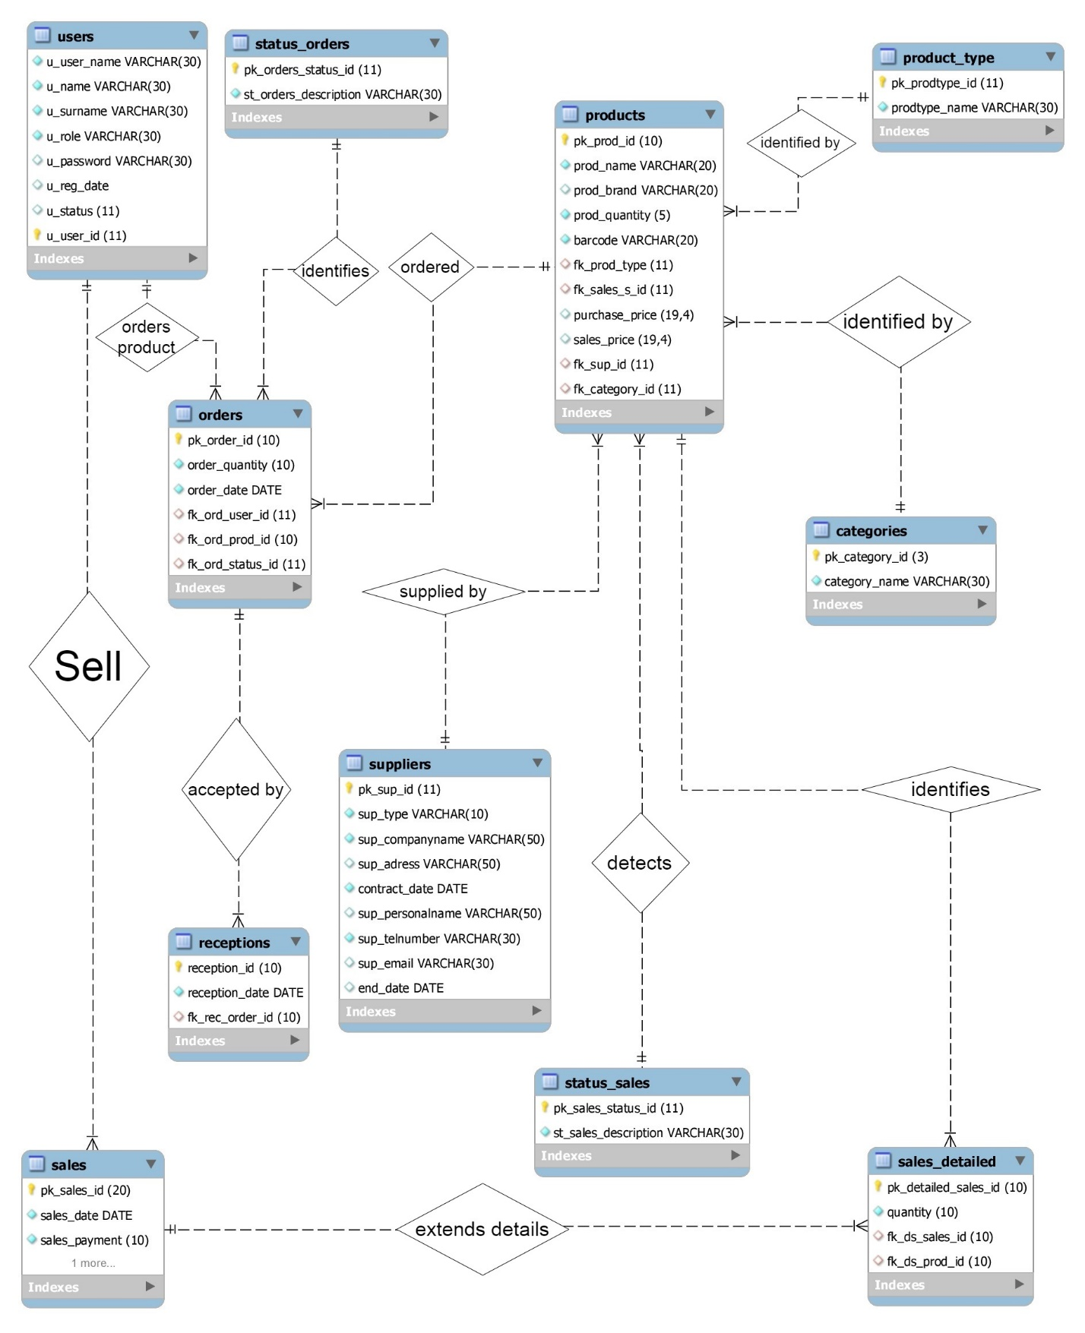

Figure 1

**Solution of given topic (Comments):**

After determining structure of system, I started to implement technical solutions. I used MySQL as DBMS and connected it with my C# WinForm Application. Most of the insert operations handled by desktop interface.   
In the following part creation and autoincerement setups will be given. Constraints such as primary,foreign key, not null, unique, default were used. For some tables I had to add additional columns during production. So, adding and modifying data type is also used.

**Create and autoincrement:**

*create database StoreManagement;*

*create table users(*

*u_user_name varchar(30) primary key,*

*u_name varchar(30) not null,*

*u_surname varchar(30) not null,*

*u_role varchar(30) not null,*

*u_password varchar(30) default '123456789',*

*u_reg_date datetime*

*);*

*alter table users add column u_status int;*

*alter table users drop primary key;*

*alter table users add column u_user_id int primary key auto_increment;*

*alter table users auto_increment = 1000;*

*alter table users add constraint u_user_name unique(u_user_name);*

*create table CATEGORIES(*

*pk_category_id int(3) primary key auto_increment,*

*category_name varchar(30) not null*

*);*

*alter table CATEGORIES auto_increment = 100;*

*create table PRODUCT_TYPE(*

*pk_prodtype_id int primary key auto_increment,*

*prodtype_name varchar(30) not null*

*);*

*create table STATUS_SALES(*

*pk_sales_status_id int primary key auto_increment,*

*st_sales_description varchar(30) not null*

*);*

*create table STATUS_ORDERS(*

*pk_orders_status_id int primary key auto_increment,*

*st_orders_description varchar(30) not null*

*);*

*create table SUPPLIERS(*

*pk_sup_id int primary key auto_increment,*

*sup_type varchar(10) not null,*

*sup_companyname varchar(50) not null,*

*sup_adress varchar(50),*

*contract_date date not null,*

*sup_personalname varchar(50),*

*sup_telnumber varchar(30) not null,*

*sup_email varchar(30)*

*);*

*alter table SUPPLIERS auto_increment = 10000000;*

*alter table storemanagement.suppliers add column end_date date;*

*create table PRODUCTS(*

*pk_prod_id int unsigned primary key auto_increment,*

*prod_name varchar(20) not null,*

*prod_brand varchar(20),*

*prod_quantity smallint unsigned not null,*

*barcode varchar(20) unique not null,*

*fk_prod_type int,*

*fk_sales_s_id int,*

*purchase_price int not null check(purchase_price >= 0),*

*sales_price int not null check(sales_price >= 0),*

*fk_sup_id int,*

*fk_category_id int,*

*foreign key (fk_prod_type)*

*references product_type(pk_prodtype_id),*

*foreign key (fk_sales_s_id)*

*references status_sales(pk_sales_status_id),*

*foreign key (fk_sup_id )*

*references suppliers(pk_sup_id),*

*foreign key (fk_category_id)*

*references categories(pk_category_id)*

*);*

*alter table products auto_increment = 1000000000;*

*alter table storemanagement.products*

*modify purchase_price decimal(19,4),*

*modify sales_price decimal(19,4);*

*create table ORDERS(*

*pk_order_id int unsigned primary key auto_increment,*

*order_quantity int unsigned not null,*

*order_date date not null,*

*fk_ord_user_id int,*

*fk_ord_prod_id int unsigned,*

*fk_ord_status_id int,*

*foreign key (fk_ord_user_id)*

*references users(u_user_id),*

*foreign key (fk_ord_prod_id)*

*references products(pk_prod_id),*

*foreign key (fk_ord_status_id)*

*references status_orders(pk_orders_status_id)*

*);*

*alter table ORDERS auto_increment = 10000000;*

*create table RECEPTIONS(*

*reception_id int unsigned primary key auto_increment,*

*reception_date date not null,*

*fk_rec_order_id int unsigned,*

*foreign key (fk_rec_order_id)*

*references orders(pk_order_id)*

*);*

*alter table receptions auto_increment = 1000000000;*

*create table SALES(*

*pk_sales_id int(20) unsigned primary key auto_increment,*

*sales_date date not null,*

*sales_payment int unsigned not null,*

*fk_sales_user_id int,*

*foreign key (fk_sales_user_id)*

*references users(u_user_id)*

*);*

*create table SALES_DETAILED(*

*pk_detailed_sales_id int unsigned primary key auto_increment,*

*quantity int unsigned not null,*

*fk_ds_sales_id int unsigned,*

*fk_ds_prod_id int unsigned,*

*foreign key (fk_ds_sales_id)*

*references sales(pk_sales_id),*

*foreign key (fk_ds_prod_id)*

*references products(pk_prod_id));*

**Creating views**

//detailes about products

*create view view_products as*

*select pk_prod_id "Product ID on system",prod_name "Name", prod_quantity "Quantity",*

*sales_price "Sales price",*

*purchase_price "Purchase price",*

*st_sales_description "Sales status",*

*prodtype_name "Product type",*

*barcode "Barcode", prod_brand "Brand name",*

*category_name "Category name",*

*sup_companyname "Supplier name"*

*from products*

*left join categories*

*on products.fk_category_id = categories.pk_category_id*

*left join suppliers*

*on products.fk_sup_id = suppliers.pk_sup_id*

*left join status_sales*

*on status_sales.pk_sales_status_id = products.fk_sales_s_id*

*left join product_type*

*on products.fk_prod_type = product_type.pk_prodtype_id;*

// Details about all received product

*create view view_Reception as*

*select pk_order_id "OrderID", prod_name "Product name",*

*order_quantity "Ordered Quantity",order_date "Ordered Date",*

*st_orders_description "Status of Order",*

*concat(u_name,u_surname) "Ordered by",*

*category_name "Category name",*

*sup_companyname "Supplier"*

*from orders*

*left join users*

*on orders.fk_ord_user_id = users.u_user_id*

*left join products*

*on products.pk_prod_id = orders.fk_ord_prod_id*

*left join status_orders*

*on status_orders.pk_orders_status_id = orders.fk_ord_status_id*

*left join categories*

*on categories.pk_category_id = products.fk_category_id*

*left join suppliers*

*on suppliers.pk_sup_id = products.fk_sup_id;*

//View for products that haven’t received yet

*create view view_Reception_active as*

*select pk_order_id "OrderID", prod_name "Product name",*

*order_quantity "Ordered Quantity",order_date "Ordered Date",*

*st_orders_description "Status of Order",*

*concat(u_name,u_surname) "Ordered by",*

*category_name "Category name",*

*sup_companyname "Supplier"*

*from orders*

*left join users*

*on orders.fk_ord_user_id = users.u_user_id*

*left join products*

*on products.pk_prod_id = orders.fk_ord_prod_id*

*left join status_orders*

*on status_orders.pk_orders_status_id = orders.fk_ord_status_id*

*left join categories*

*on categories.pk_category_id = products.fk_category_id*

*left join suppliers*

*on suppliers.pk_sup_id = products.fk_sup_id*

*where orders.fk_ord_status_id != 2;*

//view for received products

*create view view_Received as*

*select pk_order_id "OrderID", prod_name "Product name",*

*order_quantity "Ordered Quantity",order_date "Ordered Date",*

*st_orders_description "Status of Order",*

*concat(u_name,u_surname) "Ordered by",*

*category_name "Category name",*

*sup_companyname "Supplier"*

*from orders*

*left join users*

*on orders.fk_ord_user_id = users.u_user_id*

*left join products*

*on products.pk_prod_id = orders.fk_ord_prod_id*

*left join status_orders*

*on status_orders.pk_orders_status_id = orders.fk_ord_status_id*

*left join categories*

*on categories.pk_category_id = products.fk_category_id*

*left join suppliers*

*on suppliers.pk_sup_id = products.fk_sup_id*

*where orders.fk_ord_status_id = 2;*

**Inserting data to tables**

*insert into users values( 'admin0','admin ad','admin soyad','admin','admin1234',sysdate());*

*insert into users values( 'cashier2','Seyiddd','Agayev','cashier','cashier1234',sysdate());*

*insert into categories(category_name) values ('Bakery');*

*insert into product_type(product_type.prodtype_name) values ('piece');*

*insert into product_type(product_type.prodtype_name) values ('weighted');*

*insert into status_sales(st_sales_description) values ('Active');*

*insert into status_sales(st_sales_description) values ('Frozen');*

*insert into status_sales(st_sales_description) values ('Deleted');*

*insert into status_orders(st_orders_description) values ('Awaiting');*

*insert into status_orders(st_orders_description) values ('Received');*

*insert into suppliers*

*values (10000000,'local','veyseloglu','baki',date(sysdate()),'Akif Akifli','+994555555555',null);*

*insert into storemanagement.products (prod_name, prod_brand, barcode, prod_quantity,*

*fk_prod_type, purchase_price, sales_price, fk_sup_id,*

*fk_category_id,fk_sales_s_id ) values ('Apple','Dayinin magazasi','55155155151',*

*'3','1','1','2','10000000','100',1) ;*

*insert into storemanagement.orders(order_quantity,order_date,*

*fk_ord_user_id,fk_ord_prod_id,fk_ord_status_id)*

*values('2',date(sysdate()),'1006','1000000002',1);*

**Select command for multiple tasks**

//getting supplier id based on company name

*select pk_sup_id from storemanagement.suppliers where sup_companyname = 'ARAZ';*

//getting category id based on category name

*select pk_category_id from storemanagement.categories where category_name = 'BAKERY';*

//getting product type id based on type name

*select pk_prodtype_id from storemanagement.product_type where prodtype_name = 'piEce';*

// getting category, product type and company names from their own tables

*select upper(storemanagement.categories.category_name) from storemanagement.categories;*

*select upper(storemanagement.product_type.prodtype_name) from storemanagement.product_type;*

*select upper(storemanagement.suppliers.sup_companyname) from storemanagement.suppliers;*

*//Data for describing in desktop application*

*select * from storemanagement.categories order by category_name;*

*//Suppliers that have active contract*

*select pk_sup_id from storemanagement.suppliers where sup_companyname = 'ARAZ' and end_date is null;*

*//Product and their status joined together*

*select * from products*

*left join status_sales*

*on status_sales.pk_sales_status_id = products.fk_sales_s_id;*

*//getting sales status id base on status name*

*select pk_sales_status_id from storemanagement.status_sales where st_sales_description = 'active';*

*//view selections*

*select * from view_Reception;*

*select * from view_received;*

*select * from view_products;*

*select * from view_reception_active;*

*//Select specified user*

*select u_name as NAME,u_surname as SURNAME, u_user_name as USERNAME, u_role as ROLE, u_reg_date as REGISTIRATION_DATE from storemanagement.users where true and u_name ='Seyid' and u_surname ='Agayev' and u_user_name ='cashier0' ;*

**Updates:**

//deactivating user from system

*update users set storemanagement.users.u_status = 1 where users.u_status is null;*

*//changing password of selected user*

*update storemanagement.users set u_password = '123' where u_user_name = 'cas';*

*//ending contract*

*update storemanagement.suppliers set end_date = date(sysdate()) where pk_sup_id = 10000000;*

*//changing status(active,frozen,…) of given product*

*update products set fk_sales_s_id = '{0}' where pk_prod_id = '{1}';*

**Result:**

Database was suitable for C# program work without errors. Related tables protects data lose. It can be used as a prototype market management system for mini stores. Automation task, reporting and statistical reports can be easily generated.

**References:**

<https://dev.mysql.com/doc/>

<https://www.tutorialspoint.com/mysql/>

<http://www.mysqltutorial.org/mysql-views-tutorial.aspx>

<https://www.w3schools.com/sql/sql_join.asp>